Host a nuclear waste dump for £42m
new
Ben Webster, Environment Editor
January 25 2018, 5:00pm, The Times
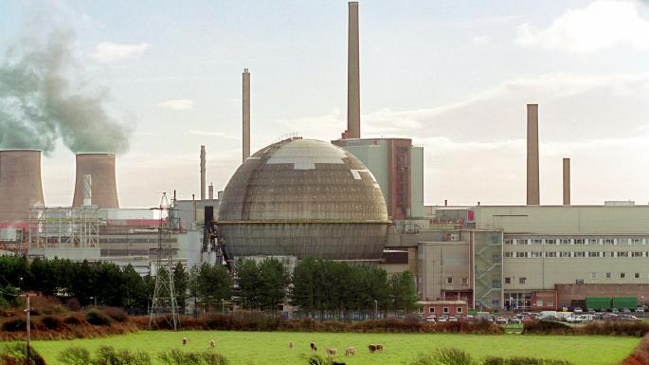
The new disposal sites would take waste currently stored at 30 sites at ground level, mainly at Sellafield in CumbriaGETTY IMAGES

Communities will receive up to £42 million if they agree to consider hosting an underground nuclear waste dump.
They can keep the money even if they ultimately decide against it, under new government plans.
The payments, which will be spread over 20 years, are aimed at persuading communities to engage in the process of selecting and testing a site for storing enough radioactive waste to fill six Albert Halls.
The Department for Business, Energy and Industrial Strategy said more than one community could receive the funding, with each receiving up to £42million.
The proposals appear to weaken the power of county councils, making it harder for them to prevent a community in their area from agreeing to host the £19 billion “geological disposal facility” (GDF).
The government is keen to avoid a repeat of what happened in 2013, when Cumbria county council vetoed plans to build a GDF near the Lake District despite the local authority, Copeland borough council, voting in favour.
A consultation document states that the final decision will be subject to a “test of public support”, which could be a local referendum.
However, the right to vote in the referendum could be restricted to a relatively small area around the proposed site, which would take waste that could remain radioactive for 100,000 years.
The decision on holding a referendum would be taken by a “community partnership” involving representatives from councils, businesses and community groups.
Communities agreeing to consider hosting the GDF would be paid up to £1 million a year for about five years, rising to £2.5 million a year for 10-15 years while boreholes were drilled to investigate whether the geology was suitable.
The money can be spent on schemes that benefit the local economy, enhance the environment or “improve community wellbeing”.
Construction is expected to start in the 2030s, with waste beginning to be buried in the 2040s at depths of between 200 metres and 1,000 metres. Up to 2,000 people would be employed building the GDF at the peak of construction and there would be 600 permanent jobs once it opened.
The site would take waste currently stored at 30 sites at ground level, mainly at Sellafield in Cumbria, and continue to receive waste for about 100 years from a new generation of nuclear plants, including one being built at Hinkley Point in Somerset.
Taxpayers would contribute £12 billion of the total cost and owners of new nuclear plants the remaining £7 billion.
Cumbria is still viewed as the most suitable location for the site because of the ease of transporting the large amount of waste at Sellafield and willingness of the local community. However, other areas with ageing or decommissioned nuclear plants have been suggested, including Dungeness in Kent and Hartlepool, in County Durham.
The GDF would take nuclear waste from England and Wales but not Scotland, which prefers to store its waste at ground level.
GDFs are already being developed in Finland, Sweden, France, and Canada.
Richard Harrington, the energy minister, said: “We owe it to future generations to take action now to find a suitable permanent site for the safe disposal of our radioactive waste. And it is right that local communities have a say. Planning consent will only be given to sites which have local support.”
Doug Parr, Greenpeace UK chief scientist, said: “Having failed to find a council willing to have nuclear waste buried under their land, ministers are resorting to the tactics from the fracking playbook — bribing communities and bypassing local authorities.
“With six new nuclear plants being planned, the waste problem is just going to get much worse. Since there is no permanent solution for the disposal of spent nuclear fuel, the responsible thing to do would be to stop producing more of it instead of just passing the radioactive buck to future generations.”
Roy Payne, a former adviser to Radioactive Waste Management, the government body tasked with building the GDF, said the new process was “quite deliberately designed to get around local authorities vetoing the project”.

